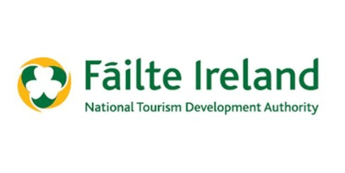
Fáilte Ireland Regional Festival & Participative Events Fund
Drawdown – Please complete and submit to tourism@longfordcoco.ie
This programme is aimed at supporting festivals and events which drive both domestic and international tourism helping to increase economic activity within the community. The objective of the scheme is to support community and voluntary groups who are organising a diverse range of projects and events. In addition, the festival or event must take place in County Longford, be a minimum of 2 consecutive days in duration and aim to attract international visitors. This fund is advertised twice a year for festivals from January to June and from July to December.
APPLICANT DETAILS

Community Group / Organisation

EVENT

Name of Event

Did the event take place over 2 consecutive days.

How many attended the event
How many of the attendees do you realistically estimate travelled from outside the county and from outside of Ireland
COST OF FESTIVAL / EVENT
The grant funding may only be used to support the festival or event approved and may not be used for any other purpose.

What was the final cost of the Event and can you please provide evidence of expenditure.

EVENT DETAILS
Can you outline the benefits of the event to the area from an economic and tourism perspective and the extent to which it contributes to the Annual Calendar of Events.

Can you outline and provide evidence of how Longford Tourism was acknowledged in the Event?

Can you outline the extent to which the event is unique, innovative, creative, interesting, and likely to have future potential.

DECLARATION
I/we certify that all information provided in this application, and all information given in any documentation submitted in support of the application is truthful and accurate.

Signed: __________________ Date: ___________________

Name __________________ Position__________________
(in block capitals): (in organisation)

Longford Tourism Contact details:
Longford Tourism
Market Square
Longford 043-3343509 / tourism@longfordcoco.ie.

