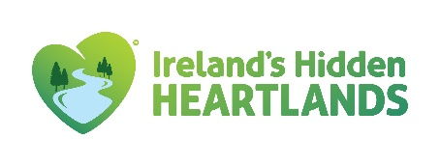 |  | 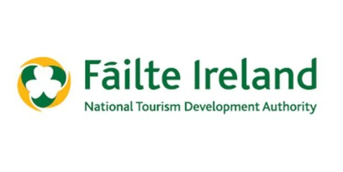
Fáilte Ireland Regional Festival & Participative Events Fund 2024
Guidelines
Closing date for submission of completed applications is close of business Friday 19th April 2024.
Longford Tourism are currently seeking applications for Round 2 of the Fáilte Ireland Regional Festival & Participative Events Fund 2024. This programme is aimed at supporting festivals and events, held from 1st July 2024 up to 31st December 2024, which drive both domestic and international tourism helping to increase economic activity within the community. The objective of the scheme is to support community and voluntary groups who are organising a diverse range of projects and events. In addition, the festival or event must take place in County Longford, be a minimum of 2 consecutive days in duration and aim to attract international visitors. This fund is advertised twice a year for festivals from January to June and from July to December.

Guidelines

This programme is aimed at festivals and events that fit into one of the following categories:
- General festivals (i.e. literary, historic, fairs, traditional culture or family focused).
- Arts, Music & Theatre.
- Family Sports & Outdoors

The following categories of festival and participative events are ineligible: ·
- Purely commercial events with limited tourism appeal.
- Agricultural shows and countryside fairs with limited tourism appeal.
- Spectator-based sporting events.
- Circuses and carnivals.
- Christmas fairs and markets.

The scheme will not fund:
- Ongoing running costs.
- Servicing of debt repayments.
- Activities where adequate statutory funding is clearly available.

The group must comply with the following:

- Have an acceptable constitution set of rules governing its membership, operations
and management.
- Have proper procedures and policies in place
- As a condition of funding, Longford Tourism ask organisations working with children to confirm that they have their own Child Safeguarding Statement and policies in place or agree to comply with the Longford Tourism Child Safeguarding Statement. (where activity includes children and young people under 18)
- Have a reasonable expectation of continuity.
- Be registered with Longford Public Participation Network.
- Provide evidence that the event has taken place (e.g. photographic evidence).
- Acknowledge Longford Tourism’s support, use the Longford Tourism logo and tag Longford Tourism on all social media activity relating to the event.
- A recent bank / post office statement, showing the group name and account details, of Income and Expenditure associated with the event
- Provide confirmation of Tax Clearance.
- Complete and return the supplier setup form. This is required for payment.
- Successful applicants and payment of the grant will be made in one instalment upon receipt of evidence of expenditure.
- The grant funding may only be used to support the festival or event approved and may not be used for any other purpose.
- Longford Tourism reserves the right to audit claims submitted.

Please note, there is no guarantee of grant assistance even if the qualifying conditions are met. Each application submitted will be evaluated on a competitive basis and a decision in relation to an offer of grant funding will be based on the following evaluation criteria:

- The benefit of the event to the area from an economic and tourism perspective.
- The extent to which proposed initiatives maximise community participation in terms of the number organising and attending the event.
- The extent to which the proposed initiative contributes to the 2024 Longford Calendar.
- The extent to which the event is unique, innovative, creative, interesting, and likely to have future potential.
- Funding received previously from this scheme. A maximum of €3,000 per organisation can be received in any one year with a maximum of 3 events funded.

Longford Tourism Contact details: 043-3343509 or tourism@longfordcoco.ie
Only completed submissions received via the approved application form will be considered and must be submitted by close of business on Friday 19th April 2024. Incomplete applications and applications received after the closing date will not be considered for grant assistance.

